|  |  |
| --- | --- |
|  | **Supplementary Regulations** |
|
|
|
| **European Championship Motocross/Snowcross** | |

**CATEGORIES**

|  |  |  |  |  |  |  |  |  |
| --- | --- | --- | --- | --- | --- | --- | --- | --- |
| **EMX65** | **EMX85** | **EMX125** | **EMX250** | **EMX2T** | **EMXOpen** | **EMXQuad** | **Women** | **SNX** |
|  |  |  |  |  |  |  |  |  |

|  |  |  |  |  |
| --- | --- | --- | --- | --- |
| **IMN:** | 223/21 | 716/01 | |  |
| **Date:** | 15-16.07.2023 | | | |
| **FMNR:** | ACCR | | | |
| **Venue:** | Loket | | | |
| **Name circuit** | | | Loketské serpentiny | |
| **Organiser/Club** | | | Automotoklub Loket v AČR | |

**ACCESS**

|  |  |  |  |  |
| --- | --- | --- | --- | --- |
| **Nearest Airport** | Vaclav Havel Airport Prague | **at** | 135 | **Km from the circuit** |
| **Motorway** | E48 | **exit** | Loket | |
| **National road** | 9 | | | |
| **Nearest Town** | Loket | | | |
| **Direction** | West | **at** | 2 | **Km from the circuit** |

**NEAREST HOSPITAL**

|  |  |  |  |  |
| --- | --- | --- | --- | --- |
| **Name** | Sokolov | **at** | 8 | **Km from the circuit** |
| **street** | Slovenská 545 | | | |
| **City** | Sokolov | | | |
| **E-mail** | (not available) | | | |
| **Telnr** | +420 352 520 111 | | | |

**STARTING NUMBERS**

|  |  |  |  |
| --- | --- | --- | --- |
| Combined INFRONT events | | INFRONT Sport Office | [sportoffice@mxgp.com](mailto:sportoffice@mxgp.com) |
| Not Combined events | | FIM Europe Start numbers | [peter.hansenmx@gmail.com](mailto:peter.hansenmx@gmail.com) |
| All riders will receive from the FIM Europe Motocross Commission a permanent starting number to be used for the entire season. Changing during the season without prior written approval of the FIM Europe Motocross Commission/ Infront Moto Racing is not possible : | | | |
| **E-mail Infront** | [sportoffice@mxgp.com](mailto:sportoffice@mxgp.com) | | |
| **Web FIME  E-mail FIM E** | <http://www.fim-europe.com/motocross-snowcross/>  [peter.hansenmx@gmail.com](mailto:peter.hansenmx@gmail.com) | | |

**OFFICIALS**

|  |  |  |  |
| --- | --- | --- | --- |
|  | **NAME** | **Federation.** | **Licence nr** |
| **FIM E Jury President** |  |  |  |
| **FIM E Delegate** | **Andrea Barbieri** | **FMI** | **4728** |
| **FIM E Steward** | **Antonio Alia** | **RFME** |  |
| **FMNR Jury Member** | **Tomáš Honzík** | **ACCR** | **2022-OFF-200015587** |
| **FIM E Race Director** | **Tomas Pavlovcik** | **SMF** |  |
| **Secretary of the Jury** | **Jaroslav Piela** | **ACCR** |  |
| **Clerk of the Course** | **Zdeněk Dvořák** | **ACCR** | **2022-OFF-200015586** |
| **Chief Technical Steward** | **Jiří Chmel** | **ACCR** | **2023-OFF-790016653** |
| **Chief Timekeeper** | **Infront Timekeeping** |  |  |
| **Environmental Steward** | **Alexandra Dašková** | **ACCR** | **2021-OFF-620014983** |
| **Chief Medical Officer** | **Marcela Maternová** | **ACCR** | **2022-OFF-720015913** |
| **Press Officer** | **Tereza Piela** | **ACCR** |  |
| **Paddock Official** | **Jaroslav Faflík** | **ACCR** |  |
| The meeting will be organized in conformity with the FIM Europe Sporting Code, the FIM E MX rules, CMS Regulations, the general rules of the ACCR (FMNR), where applicable, and these Supplementary Regulations which have been duly examined and approved by ACCR (FMNR). | | | |

1. **ORGANIZER**

|  |  |
| --- | --- |
| **Name** | Automotoklub Loket v AČR |
| **Street** | Na Vyhlídce 592 |
| **City** | Loket |
| **Phone** | +420 352 684 023 |
| **E-mail** | [dvorak.amk.loket@gmail.com](mailto:dvorak.amk.loket@gmail.com) |
| **Web Site** | [www.loketmx.com](http://www.loketmx.com/) |
| **Minimum width** | 6 m |

1. **SECRETARIAT of the MEETING**

|  |  |
| --- | --- |
| **Location** | Automotoklub Loket v AČR |
|  | Na Vyhlídce 592 |
|  | Loket |
| **Phone** | +420 352 684 023 |
| **E-mail** | [dvorak.amk.loket@gmail.com](mailto:dvorak.amk.loket@gmail.com) |

1. **ENTRIES**

|  |  |  |
| --- | --- | --- |
| **Entry Forms duly approved by the participants must be send to :** | | |
| Infront Moto Racing online entry system | | |
| **Phone** |  | |
| **E-mail** | sportoffice@mxgp.com | |
| **Not later than** |  | **(30 days before the meeting)** |

1. **WELCOME CENTER**

|  |  |
| --- | --- |
| **Location** | Near the circuit - GPS: 50º12'21.778"N, 12º45'59.778"E |
|  |  |
|  |  |
| **Phone** |  |
| **E-mail** | info@loketmx.com |

Open on:

|  |  |  |  |
| --- | --- | --- | --- |
| **Day** | **Date** | **From** | **To** |
| Thursday | 13.07. | 14:00 | 19:00 |
| Friday | 14.07. | 08:00 | 19:00 |
| Saturday | 15.07. | 08:00 | 19:00 |
| Sunday | 16.07. | 08:00 | 13:00 |

1. **CIRCUIT**

|  |  |
| --- | --- |
| **Name** | Loketské serpentiny |
| **Street** | Na Vyhlídce 592 |
| **City** | Loket |
| **GPS Coordinates** | 50º11'44.64"N, 12º45'30.54"E |
| **Length of the track** | 1586 m |
| **Minimum width** | 6 m |
| **A drawing of the circuit is attached to these regulations** | |
| **The race office must be equipped with a high speed internet connection over the whole meeting** | |

1. **TIMEKEEPING**

|  |  |
| --- | --- |
| **Name** |  |
| **E-mail** | timekeeping@mxgp.com |
| **Web Site** |  |
| The maximum fee for Transponders rent is 100,-€.  The fee has to be payed back after return of the Transponder. | |

**7 - CIRCUIT CONTROL**

Meeting point: At the starting grid.

See attached Time Schedule.

**8 - MEETING WITH THE ORGANIZERS**

Venue: Jury room.

See attached Time Schedule.

**9 - TECHNICAL CONTROL AND VERFICATIONS**

Venue: The Technical control post.

See attached Time Schedule.

**10 - JURY MEETINGS**

Venue: The Jury room.

See attached Time Schedule.

The jury room is equipped with a high speed internet connection over the whole meeting.

**11 – FUEL**

In according with FIM specifications.

**12 – INSURANCE**

The organizer has contacted a third party insurance in according with Art. 110.1 of the FIM Europe Sporting Code. This insurance includes a guarantee of the minimum amount as stipulated by the FIM Europe Management Council. The Insurance comes in effect 2 days before the first practise and ends 2 days after the meeting.

The organizer disclaims all responsibility for damage to a motorcycle, its accessories and components arising out of an accident, fire or other incident.

**13 - PROTEST AND APPEALS**

Any person or group of persons (rider, entrant, manufacturer, official, etc.), recognized by the FIM and concerned by a decision taken under the authority of the FIM Europe, may ask for redress for the consequences of that decision.

Protest must be lodged according to the FIM Europe Disciplinary and Arbitration Code and the Supplementary Regulations and be accompanied by a fee of € 350,00 or equivalent amount in local currency, returnable if the protest is justified.

In general, protests against eligibility of a rider entered, must be made before the start of the official practice.

Protests against results must be presented to the International Jury within 30 minutes following the publishing of the results.

An appeal can be made to the FIM Europe Disciplinary Commission against a decision of the International Jury.

*In case of FIM combined races an appeal can be made to the FIM Stewards Panel against a decision of the Race Direction.*

Protest entailing a fuel control: See FIM Europe MX rules.

**14 - PRICE-GIVING CEREMONY**

Venue of the prize-giving ceremony : Starting gate

See attached Timetable.

The first three riders are invited to attend the prize-giving ceremony.

Additional other riders can be invited by Infront or the organizer. Riders might also be invited for a Press Conference.

If invited attendance to the prize giving ceremony or press conference is compulsory.

**15 - INTERPRETATION OF THE SUPPLEMENTARY REGULATIONS**

The interpretation of this regulations rests entirely with the Jury or Race Direction. In case of dispute, regarding the interpretation or if there is any difference between the two official texts, the English text will prevail.

Place and date: Loket, 28.04.2023

The Clerk of the Course: Zdeněk Dvořák

Approved by FMNR: ACCR

Approved by FIM Europe :      Andrea Barbieri 04-05.2023 Date :

**Attachmend:**

Page 1: A map of the region, including the venue of the circuit

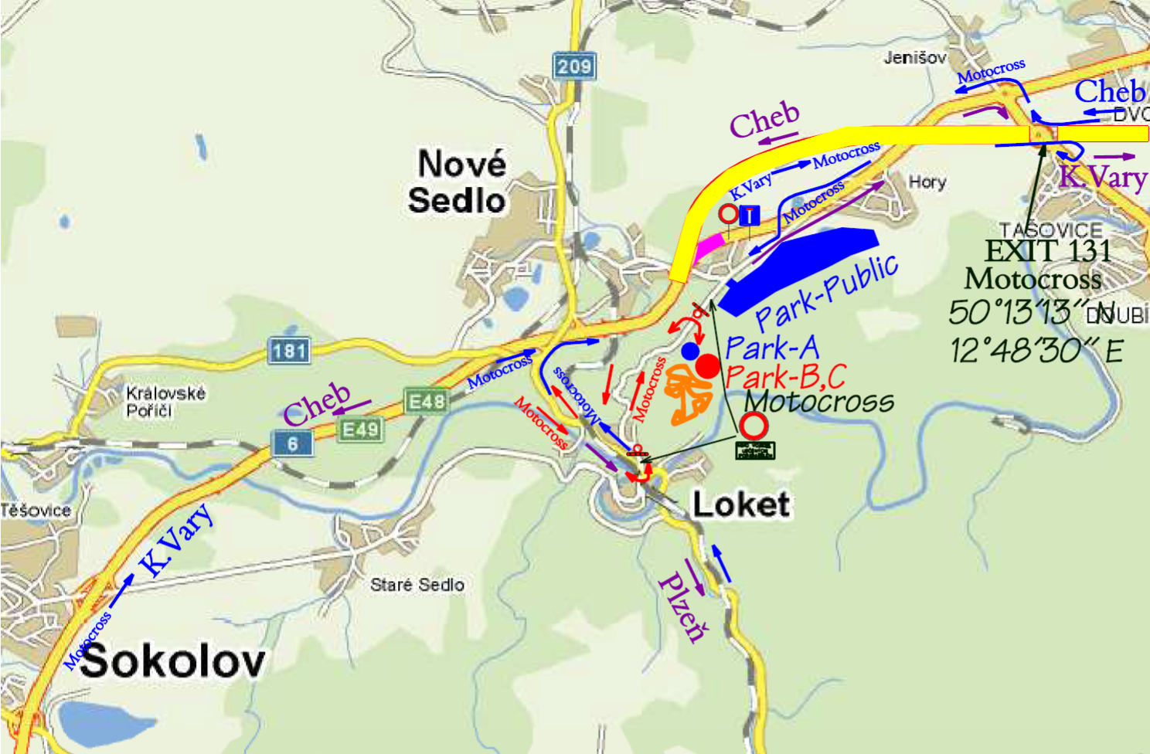

Page 2: Time Schedule

Page 3: Drawing of the circuit

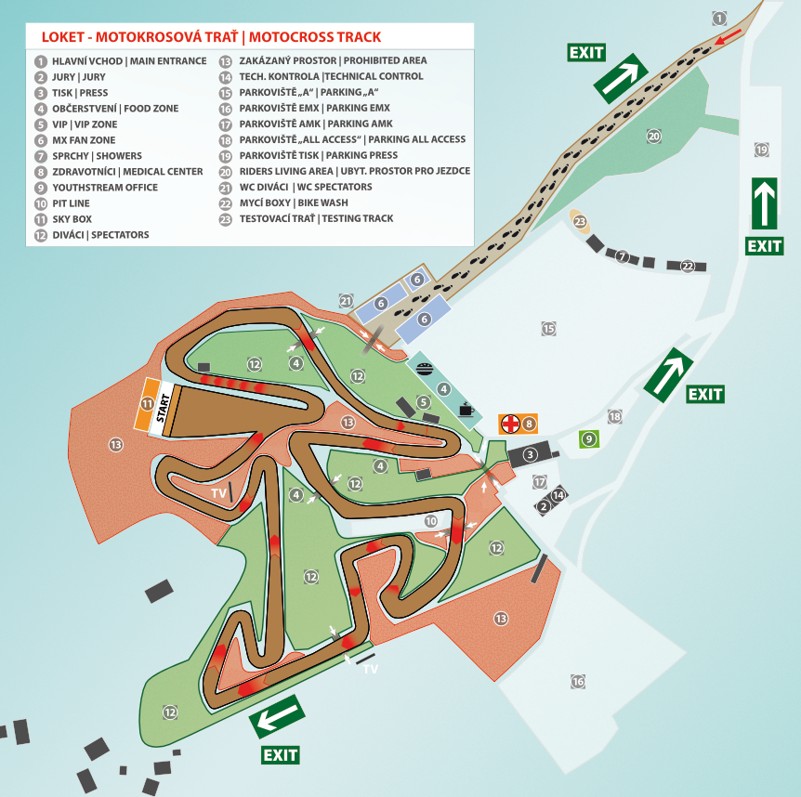

Page 4: …

Page 5: …