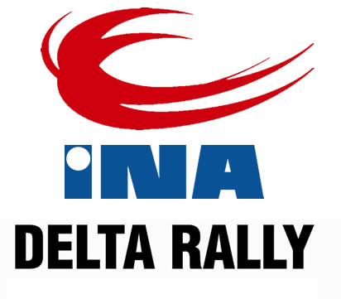
Competitor No

Zagreb, 9/10. May 2014

ENTRY FORM
ENTRY REGISTRATION FOR: (mark with X) | CEZ |  | PH |  | PSL |  | PSL  Junior

 | ENTRANT | FIRST DRIVER | CO-DRIVER
Team name
Family name
First name
Date of birth
Nationality (as passport)
Postal address
Passport number
Address for correspondence
Telephone (business)
Telephone (private)
Mobile
Fax
E mail
Competitions licence No.
Issuing ASN
Driving licence No.
Country of Issue

DETAILS OF CAR
Make |  | Country of registration
Model |  | Registration No.
Year of manufacture |  | C.C.
Class |  | Engine No
Homologation No. |  | Tech. Passport No.

Organiser’s proposed advertising accepted (choice): | YES | NO

STARTNINA
(for this entry form to be valid it must be accompanied by the appropriate entry fees, a receipt for the full amount paid to the entrants ASN, a bankers draft or details of a bank transfer etc.)

CLOSING DATE | Class 4, S1 i H | Kup S2 i S3 | Other classes
Till 18st April 2014 at 24:00 sata | 70,00 € | kn100,00 € | 130,00 €
Till 1th May 2014 at 24:00 sata | 100,00 € | 150,00 € | 200,00 €

SEEDING INFORMATION

Driver: _______________________________________

Car: ________________________________________ Class: _____________________________________

FIA Priority A YES/NO Previous FIA seed YES/NO
FIA Priority B YES/NO If yes, year ________
National seed YES/NO Priority ________
National Championship winner YES/NO If yes, championship ____________________ year ________

Year |  | Event | Car | Group | O/A Position | Class Position | No. of Finishers
Inter
Nat
Nat

IZJAVA O OBEŠTEĆENJU
The entrant, driver and co-driver jointly and severally acknowledge and agree the following:
- To abide by and be bound by the codes and regulations of the „40th INA DELTA RALLY“, held under the International Sporting Code, the Sporting and Technical Regulations of the FIA, the Regulations of the relevant National Sporting Authority ( ASN ) and the Supplementary Regulations issued for the „40th INA DELTA RALLY“.
- That motor sport is dangerous and accidents causing death, bodily damage, disability and property damage can and do happen and in consideration of the acceptance of this entry, we agree that neither the FIA, the relevant ASN, the organisers and/or promoters and their respective officers, servants, representatives and agents and any other parties shall be under any liability for our death, or any bodily injury, loss or damage which may be sustained or incurred by us as a result of participation in the „40th INA DELTA RALLY“, and to the fullest permitted by law agree to indemnity and hold harmless each of those parties.

ACKNOWLEDGEMENT AND AGREEMENT
By me signature I declare that all the information contained on the entry form is correct and that I acknowledge and agree in full to the terms and conditions of the above indemnity and that I accept all the terms and conditions relating to my participation in this event.

ASN Stamp* | Signature of Entrant | Signature od First Driver | Signatere of Co-driver

* Or letter from the entrant’s ASN authorising and approving the entry

Date ___________________________________ E-mail for entries: entry@inadeltarally.eu

